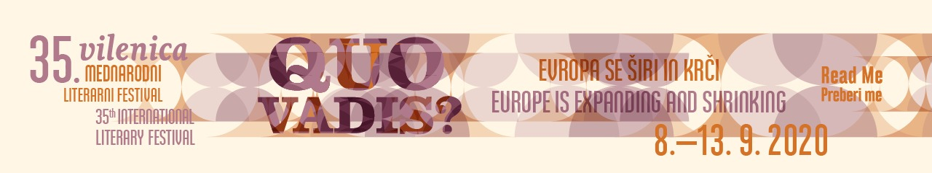

Vilenica Prize recipient 2020: Mila Haugová
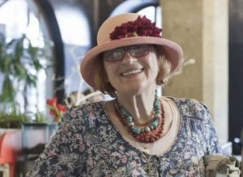
Mila Haugová Photo© David Koronczy
The Vilenica jury – consisting of Aljoša Harlamov (President), Tone Peršak (Vice President), Matej Bogataj, Ludwig Hartinger, Aljaž Koprivnikar, Martin Lissiach, Amalija Maček, Aleš Mustar, Andrej Pleterski, Julija Potrč, Jutka Rudaš and Đurđa Strsoglavec – have awarded the Vilenica 2020 Prize to Mila Haugová.
Biography
Prepared by Aljaž Koprivnikar, member of the Vilenica Jury
Slovak poet and translator Mila Haugová was born in Budapest on 14 June 1942. The daughter of a Slovakian father and a Hungarian mother, she grew up bilingual. Soon after her birth the family moved from Hungary to present-day Ukraine, and then after World War 2 to Vráble, a town in the then Czechoslovakia. The family encouraged her love of books and literature. They moved often until settling in Nitra, where Haugová finished primary school. In 1951, her father was declared class enemy by new authorities and jailed for two years, while Haugová was not allowed to study German and aesthetics. She was able to enrol in the Higher Agricultural College in Nitra, graduating in 1964. She first worked as an agronomist for a year and then as a secondary school teacher. While on her honeymoon in Yugoslavia in August 1968, she found out that Czechoslovakia was occupied by the Soviet military. She emigrated to Canada with her husband the next month and returned home after nine months. After giving birth to her daughter in 1972, she moved to Bratislava where she worked as the editor of the renowned Romboid literary journal from 1986 to 1996, which was linked to her own literary aesthetics.
She says she gradually took command of her own life, created a family after having grown both as a person and as an author. She wrote between the countryside, Zajačia Dolina (Levice) and Bratislava, the capital. She taught creative writing for many years and urged young poets to be sincere and clear in their writing while creating her own enviable body of works, which includes 23 collections of poetry and many self-reflective works of fiction. She has enjoyed great recognition and popularity among Slovak literary circles and readers for four decades. Her poetry opens the space of invisible feelings that help her study human souls and personal relationships, including between men and women, mothers and daughters, and the like. She often writes about how we all belong together: plants, animals, stars, etc. Her poems are like lectures on humanity and care for the life of all living beings: “the plants are slow animals / I am a slow animal / where I come from…”. The poetry of Mila Haugová travels between the reflective and the imaginative, between intellectual and intimate lyrics and philosophical consideration, pulsating with the harmony of the universe and complicated relations between a man and a woman that have remained the central themes in her writing. She has received many international and national awards, including the most esteemed Slovak award for writing, the Dominik Tatarka Prize, and the award of the Ministry of Culture for long-term exceptional contribution to original writing and translation. Her poetic journey has followed her basic creative tenet: an attempt to heal the wounds of the world through poetry and writing.
In her long career, Mila Haugová has visited many literary festivals and attended many residency programmes, while her poetry has been translated into most European languages. She has also been a prolific translator herself, having translated the work of Sylvia Plath, Anna Sexton, Ted Hughes, Jamesa Wright, Carolyn Forché, Ingeborg Bachmann, Georg Trakl, Paul Celan, Friedericke Mayröcker and others, and a mentor to younger Slovak poets. Her persistence in poetic call and reaching beyond convention have placed her among the giants of Central European and world literature.

